PRACTICAL-10 HASHING
Aim:- Implement a suitable hashing function to insert elements in hash table. In case of collision, use separate chaining as a resolution technique. Print the hash table after inserting all the values.
Theory:- First we defined size which is the mod to 10 so we would have index from 0 to 9. After that we created a linked list for the separate chaining and also a createNode function. After that we made a hash function which would return the index of the key we give it. In index function we would first create a new node. If the index, which we got from hash function, has null in it than it will directly assign it or else we first give new node’s next the node present in the index of the hash table and then assign the new node to that index of the hash table. After that we simply print the hash table.
Code:-
#include <stdio.h>
#include <stdlib.h>
#define SIZE 10
struct Node
{
int data;
struct Node* next;
};
struct Node *hashTable[SIZE];
struct Node *createNode(int value)
{
struct Node *newNode=(struct Node *)malloc(sizeof(struct Node));
newNode->data=value;
newNode->next=NULL;
return newNode;
}
int hashFunction(int key)
{
return key%SIZE;
}
void insert(int value)
{
int index=hashFunction(value);
struct Node *newNode=createNode(value);
if (hashTable[index]==NULL)
{
hashTable[index]=newNode;
}
else
{
newNode->next=hashTable[index];
hashTable[index]=newNode;
}
}
void printHashTable()
{
for (int i=0;i<SIZE;i++)
{
printf("%d --> ",i);
struct Node *temp=hashTable[i];
while (temp!=NULL)
{
printf("%d -> ",temp->data);
temp=temp->next;
}
printf("NULL\n");
}
}
int main()
{
for (int i=0;i<SIZE;i++)
hashTable[i]=NULL;
int n,value;
printf("Enter number of values to insert:-");
scanf("%d",&n);
printf("Enter %d values:-\n",n);
for (int i=0;i<n;i++)
{
scanf("%d",&value);
insert(value);
}
printf("\nHash Table:\n");
printHashTable();
return 0;
}
Output:-
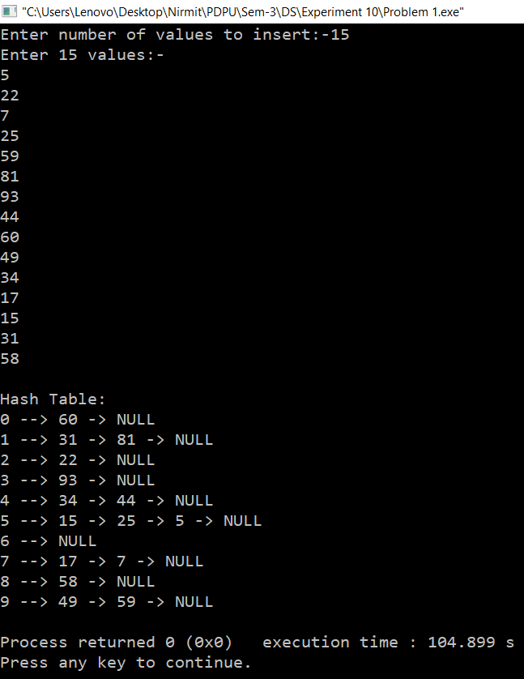
Time Complexity:- For every function instead of printHashTable() Time complexity is O(1). In printHashTable() complexity is O(size+n) where size is predefined to 10 and n is the length of linked list in that particular index so it’s complexity is O(n). So overall complexity is O(n).
Space Complexity:- O(n) as it depends on the nodes in the linked list.

